[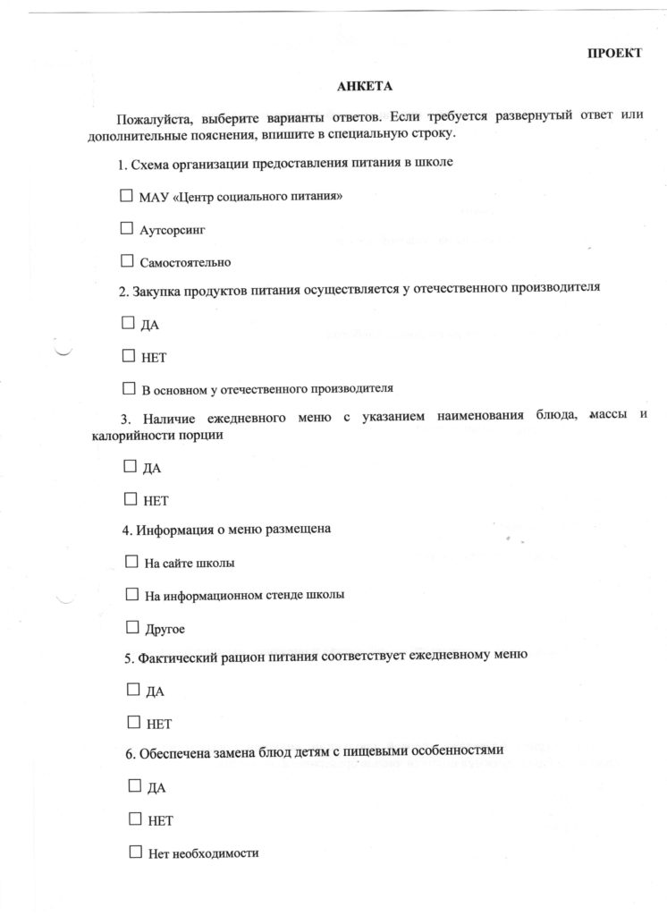](https://shkola41.ru/wp-content/uploads/2022/10/%D0%90%D0%BD%D0%BA%D0%B5%D1%82%D0%B01.jpeg)